Look before you bring it home
Look for black spots or bed bugs in any crack where you could fit a credit card.
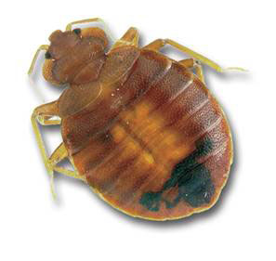
Don’t get items that have signs of bed bugs.
Signs are black spots or bugs.
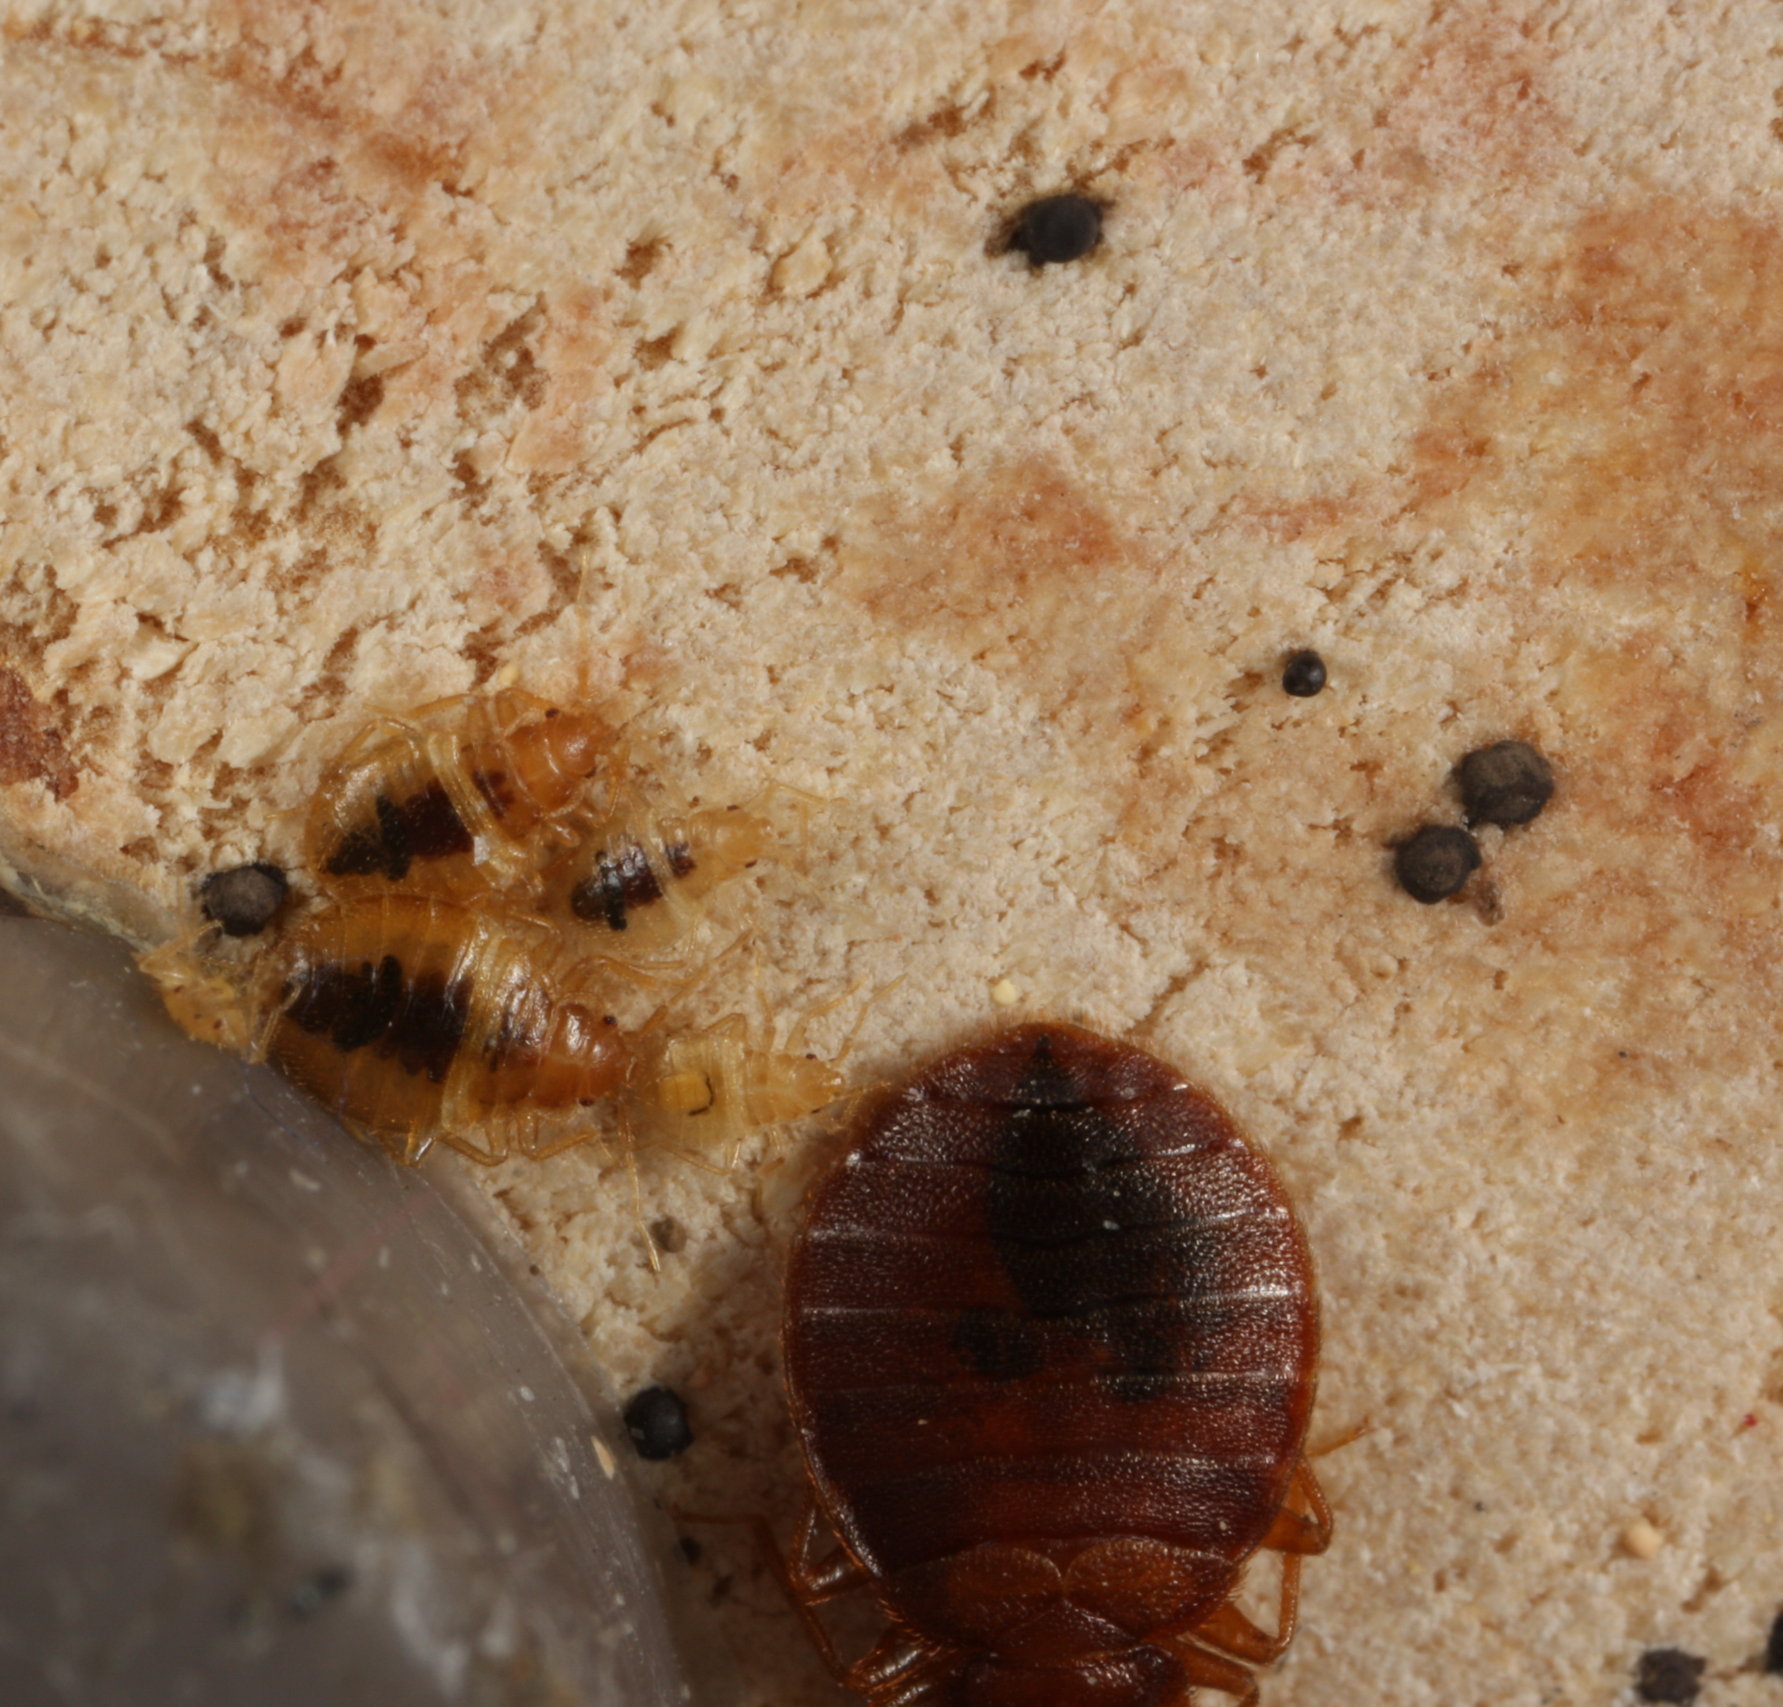
Actual size of bed bugs & black spots
Use a dryer to kill bugs
Put fabric items (pillows, blankets, stuffed animals, etc.) in a hot dryer for 30 minutes before donating them to this space.
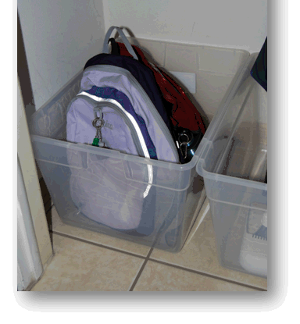
Don’t put your belongings on chairs
While using this space, don’t set your stuff on chairs. Bed bugs can travel on coats and purses. Use plastic bins, coat hooks, or leave your stuff at home.

Clean this space monthly
Date | Initials | Checked pest monitors | Inspected seating | Vacuumed | Notes
 |  | Yes / No | Yes / No | Yes / No
 |  | Yes / No | Yes / No | Yes / No
 |  | Yes / No | Yes / No | Yes / No
 |  | Yes / No | Yes / No | Yes / No
 |  | Yes / No | Yes / No | Yes / No
 |  | Yes / No | Yes / No | Yes / No
 |  | Yes / No | Yes / No | Yes / No
 |  | Yes / No | Yes / No | Yes / No
 |  | Yes / No | Yes / No | Yes / No
 |  | Yes / No | Yes / No | Yes / No
 |  | Yes / No | Yes / No | Yes / No
 |  | Yes / No | Yes / No | Yes / No

